**Audit Course Report**

On

**Entrepreneurship** **Development**

By

Giramkar Shrushti Ankush

Roll No: 19

Under the guidance

of

**Dr. Suryawanshi.A.P**

Year of Submission: 2024-2025



HSBPVT’S

PARIKRAMA FACULTY OF ENGINEERING, KASHTI

DEPARMENT OF COMPUTER ENGINEERING

**HSBPVT’s GOI Faculty of Engineering, Kashti**

DEPARTMENT OF COMPUTER ENGINEERING

KASHTI



This is to certify that **Miss. Giramkar Shrushti Ankush** from **Fourth Year Computer Engineering** has successfully completed her Audit Course work titled **“Entrepreneurship** **Development”** at HSBPVT’S of Engineering, Kashti in the partialfulfilment of the Bachelor’s Degree in Engineering of Savitribai Phule Pune University.

**Dr. Suryawanshi.A. P**

**Guide Name**

**ABSTRACT**

Entrepreneurship plays a pivotal role in driving economic growth, fostering innovation, and creating jobs. This report explores the key elements necessary for the success of startups, highlighting the entrepreneurial qualities, government regulations, and favorable environments that support business ventures. The qualities of successful entrepreneurs, including adaptability, leadership, and innovation, are discussed alongside the challenges they face, such as accessing capital and navigating complex regulatory frameworks.

A roadmap for setting business goals and methodologies is outlined, with insights from case studies like Flipkart and Tesla, showcasing how strategic planning and adaptability lead to successful outcomes. Essential skills such as communication, analytical thinking, and technical expertise are highlighted as crucial for entrepreneurial success.

Additionally, this report covers the importance of resource generation, focusing on technical, financial, and legal aspects like intellectual property protection and business associations. Finally, the report delves into key deliverables and milestones that startups must achieve, stressing the importance of scaling effectively and preparing for successful exits, often through mergers and acquisitions.

The report aims to provide a comprehensive overview of the entrepreneurial journey, offering insights and actionable strategies for aspiring entrepreneurs to succeed in the ever-evolving business landscape.

**TABLE OF CONTENTS**

|  |  |  |
| --- | --- | --- |
| **Sr. No** | **Title** | **Page. No** |
| 1 | Introduction | 5 |
| 2 | Entrepreneur | 6 |
| 3 | Road Map | 8 |
| 4 | Skill Sets | 10 |
| 5 | Functional plans | 13 |
| 6 | Entrepreneurial Finance | 14 |
| 7 | Enterprise Management | 16 |
| 8 | Conclusion | 18 |
| 9 | References | 19 |

**INTRODUCTION**

Entrepreneurship is the cornerstone of innovation and economic development. It involves the process of identifying opportunities, organizing resources, and creating value by launching new ventures. Entrepreneurs are individuals who possess the ability to turn ideas into viable business models, taking on financial, personal, and professional risks to bring new products and services to market. Entrepreneurship is not limited to starting new companies; it encompasses creating value in various forms, including non-profit initiatives and social enterprises. The entrepreneurial process is essential to solving critical societal problems, driving economic growth, and improving quality of life.

In today’s globalized economy, the importance of startups cannot be overstated. Startups are often the drivers of innovation, bringing disruptive technologies and novel business models to traditional industries. The startup ecosystem thrives on creativity, rapid adaptation, and a relentless pursuit of growth, making it a critical element of both national and global economies. Startups contribute significantly to job creation, particularly in technology-driven sectors, and they are at the forefront of addressing modern challenges such as sustainability, digital transformation, and healthcare innovation.



Entrepreneurship and startups represent the future of business, driving technological advancement, economic growth, and societal progress. Governments, institutions, and private investors must continue to foster a conducive environment for startups, ensuring access to the resources they need to succeed. As new challenges arise.

Entrepreneurship and startups are pivotal in shaping the future of business, acting as key drivers of technological advancement, economic growth, and societal progress. These ventures introduce innovative solutions that disrupt traditional industries, pushing boundaries in areas like artificial intelligence, green technology, and digital transformation. Startups have the agility and creativity to address global challenges, from climate change to healthcare, often in ways that larger, more established companies cannot.

Governments, institutions, and private investors play a crucial role in fostering a conducive environment for these businesses. Through supportive policies, financial backing, and mentorship programs, these stakeholders help create a thriving ecosystem where startups can flourish. Key factors like access to capital, streamlined regulations, protection of intellectual property, and a network of support are essential to the success of new ventures.

As the world faces new challenges whether economic, social, or environmental—startups will continue to be at the forefront, offering innovative solutions and driving sustainable development. The entrepreneurial spirit, with its focus on innovation and growth, will remain critical in the ever-evolving landscape of global business.

**ENTREPRENEUR**

When discussing entrepreneurship, it's essential to explore the qualities and strengths of successful entrepreneurs, the challenges they face, and the impact of government regulations and taxes. Here’s a comprehensive overview:



**Qualities of Successful Entrepreneurs:**

1. **Visionary Thinking**: Entrepreneurs often possess the ability to see potential where others may not, envisioning innovative solutions and future possibilities.
2. **Resilience**: The entrepreneurial journey is fraught with challenges. Resilience helps entrepreneurs bounce back from failures and setbacks.
3. **Risk-Taking**: A willingness to take calculated risks is crucial. Entrepreneurs must evaluate potential rewards against the risks involved.
4. **Adaptability**: The business landscape is ever-changing. Successful entrepreneurs can pivot their strategies in response to market changes.
5. **Strong Work Ethic**: Entrepreneurs are typically self-motivated and willing to put in long hours to achieve their goals.
6. **Leadership Skills**: The ability to inspire and manage a team is vital for turning visions into reality.
7. **Customer-Centric Approach**: Understanding and addressing customer needs is fundamental to creating value and achieving business success.

**Strengths of Entrepreneurs:**

1. **Innovation**: Entrepreneurs drive innovation by introducing new products, services, or processes that can disrupt industries.
2. **Economic Contribution**: They create jobs, stimulate economic growth, and contribute to local and national economies.
3. **Flexibility**: Entrepreneurs can respond quickly to market demands and changes, allowing for quicker decision-making compared to larger corporations.
4. **Networking Skills**: Successful entrepreneurs often build extensive networks, which can provide support, mentorship, and opportunities.
5. **Financial Independence**: Entrepreneurship can lead to significant financial rewards, allowing for personal and professional freedom.

**Challenges Faced by Entrepreneurs:**

1. **Funding**: Access to capital can be a significant hurdle, especially for startups. Entrepreneurs often struggle to secure funding through loans, investors, or grants.
2. **Market Competition**: Intense competition can make it challenging to gain market share and establish a brand presence.
3. **Regulatory Compliance**: Navigating the complex landscape of regulations and compliance requirements can be overwhelming.
4. **Work-Life Balance**: Entrepreneurs often work long hours, making it challenging to maintain a healthy work-life balance.
5. **Uncertainty and Risk**: The potential for failure is high, and many entrepreneurs face uncertainty in their business ventures.

**Government Regulations & Taxes:**

1. **Business Licenses and Permits**: Entrepreneurs must understand the specific licenses and permits required to operate legally in their industry and locality.
2. **Tax Obligations**: Entrepreneurs need to be aware of various tax obligations, including income tax, self-employment tax, sales tax, and payroll taxes. Understanding these taxes is crucial for financial planning.
3. **Employment Laws**: Compliance with labour laws, including minimum wage, overtime pay, and workplace safety regulations, is necessary when hiring employees.
4. **Intellectual Property Regulations**: Entrepreneurs should be aware of laws related to trademarks, patents, and copyrights to protect their innovations.
5. **Environmental Regulations**: Depending on the industry, there may be environmental regulations that businesses must comply with, impacting operational practices.
6. **Incentives and Grants**: Governments often provide various incentives, grants, and programs to support startups and small businesses, which can be beneficial for entrepreneurs.

**Road Map**

A well-defined road map for entrepreneurship development includes a series of actionable steps for goal setting, methodology, and analysing case studies. Below is a general outline you can follow:

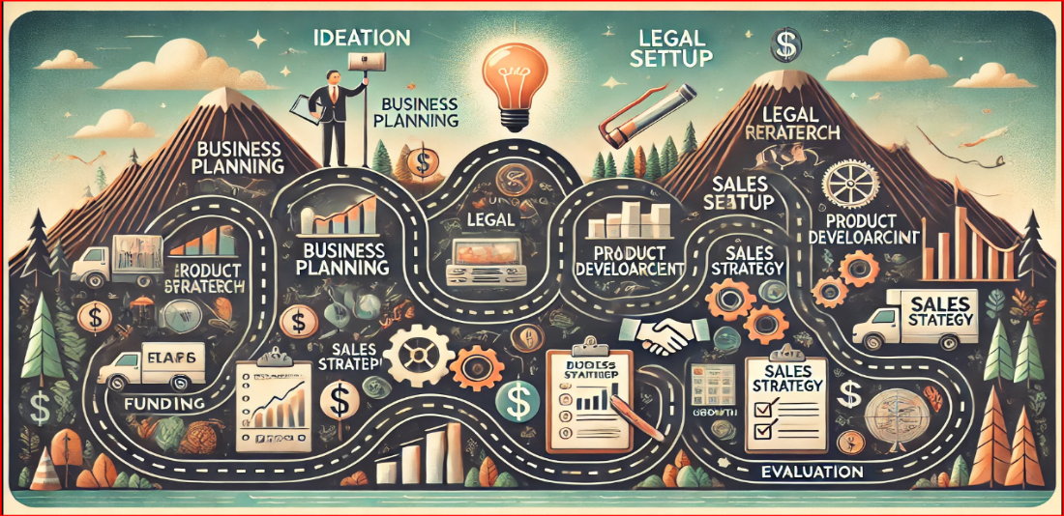

**1.** **Goal Setting:**

Setting clear and measurable goals is crucial for entrepreneurship development. These goals should align with the vision and mission of the entrepreneurial venture.

**Vision and Mission Statement:**

* **Vision**: A long-term objective describing the desired impact of the business on society.
* **Mission**: Specific, achievable, and time-bound objectives that outline what the business seeks to accomplish in the near future.

**SMART Goals**

* **S**pecific: Goals should be clear and well-defined.
* **M**easurable: Establish concrete criteria for measuring progress.
* **A**chievable: Set realistic goals within your resources and constraints.
* **R**elevant: Align the goals with your business vision.
* **T**ime-bound: Set a deadline for achieving the goals.

**2.** **Methodology:**

This involves the approach to turning your vision into reality through strategic planning, market analysis, and execution.

**Research and Market Analysis:**

* **Identify target market**: Who are your potential customers?
* **Analyze competitors**: Understand your competitors’ strengths and weaknesses.
* **Industry trends**: Stay updated on the latest trends and innovations in your industry.

**Business Model Development**

* **Value Proposition**: What unique value does your product/service offer.
* **Revenue Model**: How will the business generate income.
* **Customer Segments**: Define your customer base and market segmentation.
* **Key Resources and Partners**: Identify the resources and partnerships required to achieve your business goals.

**Prototyping and Testing**

* Develop a Minimum Viable Product (MVP) or prototype.
* Conduct customer feedback and usability testing.
* Iterate based on feedback before scaling up.

**3.Case Studies:**

Analyzing real-life case studies of successful entrepreneurial ventures is a valuable learning tool. Here are a few notable cases across different industries:

**Case Study 1: Airbnb**

* **Problem**: Founders Brian Chesky and Joe Gebbia struggled to pay rent and decided to rent out air mattresses in their apartment during a conference.
* **Solution**: They created a platform for people to rent out spare spaces, disrupting the hospitality industry.
* **Key Takeaways**:
  + Leverage underutilized resources.
  + Adaptability: The platform initially struggled but iterated until it fit market needs.
  + Community-building: Airbnb fostered trust and community among hosts, travellers.

**Case Study 2: Dropbox**

* **Problem**: Founder Drew Houston found existing file-sharing methods cumbersome.
* **Solution**: He created an easy-to-use cloud storage solution, Dropbox.
* **Key Takeaways**:
  + Solve a real pain point (file sharing and storage).
  + Build virality into your product (Dropbox's referral program was key to its growth).
  + Focus on simplicity and user experience.

**Case Study 3:** **Zomato**

* **Problem**: Deepinder Goyal and Pankaj Chaddah noticed that finding restaurant menus was difficult for office employees.
* **Solution**: Zomato started by scanning restaurant menus and publishing them online.
* **Key Takeaways**:
  + Solve small but persistent problems.
  + Expand based on data-driven insights.
  + Continuously evolve the product.

**Skill Sets**

A **skill set** refers to the combination of abilities, knowledge, and expertise that an individual possesses, enabling them to perform tasks, solve problems, and achieve goals in various areas of life. Skill sets are typically categorized based on the type of tasks they apply to, such as technical skills for engineering, soft skills for communication, or analytical skills for problem-solving.



**1. Communication Skills:**

Communication skills encompass both verbal and non-verbal methods of conveying information. Effective communication is crucial for personal interaction, teamwork, and business success.

**Verbal Communication:**

* **Clarity**: The ability to articulate ideas clearly and concisely. Example: During a presentation or meeting, ensuring that the message is structured and straightforward.
* **Active Listening**: Engaging with what others are saying by giving full attention, asking clarifying questions, and responding thoughtfully. Example: In a team discussion, actively listening to others' ideas before formulating a response.
* **Persuasion**: Convincing others to understand, accept, or adopt a particular idea, strategy, or solution. Example: Presenting a business pitch to investors with compelling arguments backed by data.

**Non-Verbal Communication:**

* **Body Language**: Understanding and using gestures, facial expressions, and posture to support verbal communication. Example: Maintaining eye contact during conversations to build trust and engagement.
* **Tone of Voice**: The pitch, speed, and volume used when speaking can significantly influence how a message is perceived. Example: Using a calm and confident tone when addressing a team during a stressful situation.

**2. Linguistic Skills**

Linguistic skills relate to proficiency in language and the ability to effectively use language in communication. These skills are important in both native and foreign languages.

**Language Proficiency:**

* **Vocabulary**: Having a broad range of words and phrases to communicate ideas effectively. Example: Using precise terminology in a legal document or technical report.
* **Grammar and Syntax**: Understanding the rules that govern sentence structure and word use. Example: Writing grammatically correct and fluid sentences for professional correspondence.
* **Multilingualism**: The ability to speak and write in multiple languages. Example: Being fluent in both English and Spanish to engage a broader audience in international business settings.

**Reading Comprehension:**

* **Understanding Complex Texts**: The ability to grasp the meaning of sophisticated texts and ideas. Example: Reading and understanding technical manuals, research papers, or legal contracts.
* **Critical Reading**: The ability to analyze and critique written content, identifying key points, underlying assumptions, and biases. Example: Reviewing research data critically to assess its validity.

**3.Analytical Skills**

Analytical skills are the ability to collect, interpret, and use data to solve problems and make decisions. These skills are essential in data-driven industries and for roles requiring problem-solving.

**Problem-Solving:**

* **Logical Thinking**: Breaking down problems into smaller parts and systematically finding solutions. Example: Troubleshooting technical issues by analyzing each step of a system’s operation.
* **Critical Thinking**: Evaluating information to make reasoned judgments. Example: Deciding between business strategies based on their potential return on investment and risk.
* **Data Analysis**: The ability to interpret data, identify patterns, and draw conclusions. Example: Analyzing sales data to determine which products are most profitable and why.

**Research Skills:**

* **Data Gathering**: Collecting accurate and relevant information through various methods like surveys, experiments, or market research. Example: Conducting market research to understand customer preferences before launching a new product.
* **Quantitative Analysis**: Working with numbers, statistics, and financial data to draw insights. Example: Using statistical software like Excel or R to analyze survey data or financial performance.

**4. Engineering Skills:**

Engineering skills are specialized technical skills used in designing, building, and maintaining systems, products, and infrastructures.

**Technical Expertise:**

* **Knowledge of Engineering Principles**: Understanding core principles of physics, mathematics, and material science. Example: Using thermodynamics principles to design energy-efficient systems.
* **Programming and Coding**: Familiarity with coding languages such as Python, C++, or Java to build software solutions. Example: Writing algorithms to optimize data processing for real-time applications.
* **CAD (Computer-Aided Design)**: Proficiency in using CAD software to create and modify designs. Example: Using AutoCAD or SolidWorks to design mechanical parts or systems.

**Project Management:**

* **Time Management**: Planning and executing projects within set timeframes and budgets. Example: Ensuring a construction project meets deadlines by coordinating effectively with contractors.
* **Resource Management**: Allocating materials, labour and equipment to meet project requirements efficiently. Example: Managing resources for a software development project to ensure on-time delivery.

**5. Teamwork and Leadership Skills:**

Collaborating effectively within a team and leading others are crucial in any professional environment, particularly in entrepreneurial ventures and engineering projects.

**Team Collaboration:**

* **Collaboration**: The ability to work well with others, sharing ideas and responsibilities. Example: Working with cross-functional teams to bring a product from concept to launch.
* **Conflict Management**: Navigating interpersonal issues to maintain a positive team dynamic. Example: Resolving disagreements about project direction in a constructive manner.

**Leadership:**

* **Delegation**: Assigning tasks based on team members’ strengths and monitoring progress. Example: Delegating research tasks to team members with the relevant expertise.
* **Motivation and Inspiration**: Encouraging and leading teams to perform at their best. Example: Providing guidance and support during challenging projects to keep team morale high.

**FUNCTIONAL PLAN**

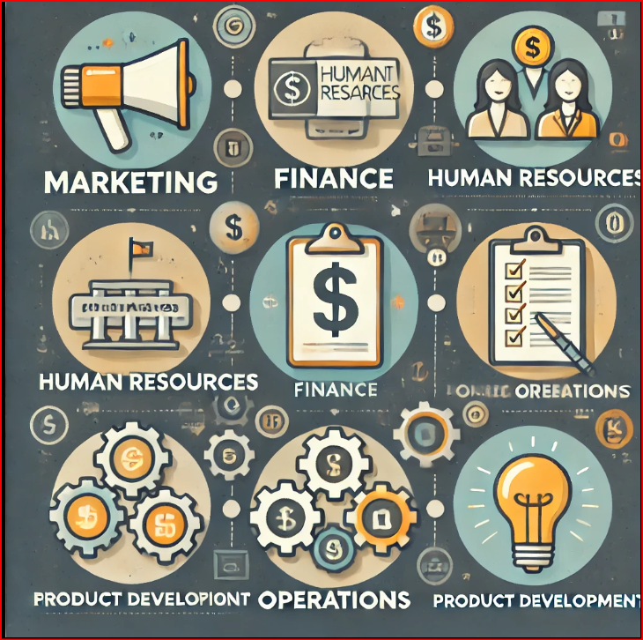

Functional plans are detailed, department-specific strategies that align with an organization’s overall business goals. They break down the company's broader objectives into specific actions and responsibilities for each functional area, such as marketing, finance, human resources, operations, and product development.

**Key Components of Functional Plans:**

1. **Purpose and Objectives**:
   * Each functional plan begins with clear objectives that align with the company's overall strategy.
   * Example: If the company’s goal is to increase market share, the marketing department’s objective might be to expand brand awareness through targeted campaigns.
2. **Roles and Responsibilities**:
   * Each functional plan outlines the roles and tasks assigned to team members within that specific department.
   * Example: The finance department might focus on managing cash flow, controlling expenses, and ensuring profitability.
3. **Budgeting and Resource Allocation**:
   * Functional plans typically include details about budgets, resources, and timeframes required to achieve the department's objectives.
   * Example: The operations team may allocate resources for supply chain management, ensuring timely production and distribution.
4. **Time Frame**:
   * These plans include timelines for achieving specific targets or milestones within a set period.
   * Example: A sales department might have quarterly goals for increasing sales revenue.

**Examples of Functional Plans:**

1. **Marketing Plan**:
   * Focuses on how to promote products or services, attract customers, and increase brand awareness.
   * Includes strategies for digital marketing, advertising, content creation, and customer engagement.
2. **Financial Plan**:
   * Details the management of the company’s finances, including budgeting, cash flow management, and forecasting.
   * Includes investment strategies, cost-cutting measures, and funding requirements.
3. **Operations Plan**:
   * Focuses on the production, manufacturing, and supply chain processes.
   * Details how to efficiently manage resources, streamline operations, and ensure timely delivery of products or services.
4. **Human Resources (HR) Plan**:
   * Outlines recruitment, employee development, training, and performance management strategies.
   * Includes plans for workforce expansion, talent retention, and creating a positive work culture.

**Benefits of Functional Plans:**

* **Clarity**: Provides a clear path for each department, ensuring alignment with the overall business strategy.
* **Accountability**: Defines specific roles, responsibilities, and KPIs for each team, fostering accountability.
* **Efficiency**: Helps optimize resource allocation by focusing efforts on the most impactful activities.
* **Coordination**: Ensures that different functional areas work in harmony towards the same corporate objectives.

**ENTREPRENEURIAL FINANCE**

**Entrepreneurial finance** involves the financial management of a new or growing business venture. It focuses on understanding and managing the financial resources necessary for a startup or small business to survive, grow, and achieve its goals. Here's a detailed breakdown of the key aspects of entrepreneurial finance:



**Understanding Startup Costs:**

Every entrepreneurial venture begins with initial costs that cover launching and setting up the business. These include:

* **Product Development Costs**: Expenses related to developing and refining the product or service, including research, design, and prototyping.
* **Legal and Licensing Fees**: Costs associated with registering the business, filing patents, securing licenses, and legal compliance.
* **Marketing and Branding Costs**: Budget for creating brand identity, marketing materials, and promoting the business.
* **Technology and Infrastructure**: Costs related to acquiring equipment, technology platforms, and any required physical infrastructure.

**Sources of Funding:**

Entrepreneurial finance involves finding the right mix of funding to fuel growth. Here are the main funding sources for entrepreneurs:

* **Personal Savings**: Entrepreneurs often use their own savings to fund the business, especially in the early stages (bootstrapping).
* **Friends and Family**: This informal financing source involves borrowing from close contacts who believe in the entrepreneur’s vision.
* **Angel Investors**: High-net-worth individuals who provide funding to startups in exchange for equity ownership. They often invest in early-stage companies.
* **Venture Capital (VC)**: Professional investment firms that provide capital to startups in exchange for equity, typically at later stages when the business shows growth potential.
* **Crowdfunding**: Platforms like Kickstarter and Indiegogo allow entrepreneurs to raise small amounts of money from a large number of people by pitching their ideas directly to the public.

**Valuation of the Business:**

Entrepreneurs need to understand how their business is valued, particularly when seeking outside investors. Business valuation determines the worth of the company, which is essential when offering equity to investors.

* **Pre-Money Valuation**: The value of a company before it receives outside investment or financing.
* **Post-Money Valuation**: The company’s value after receiving investment, including the new funds raised.

**Financial Statements and Analysis:**

Entrepreneurs need to regularly monitor financial performance using key financial statements:

* **Income Statement**: Shows the company’s revenue, expenses, and profit or loss over a specific period.
* **Balance Sheet**: Provides a snapshot of the company’s financial position, showing assets, liabilities, and equity.
* **Cash Flow Statement**: Tracks the flow of cash in and out of the business, which is critical for understanding liquidity.

**Enterprise Management**

Enterprise Management plays a crucial role in entrepreneurship development by providing the framework and tools necessary for entrepreneurs to start, manage, and grow their businesses effectively. Here are some key aspects of how enterprise management relates to entrepreneurship development:



**Business Planning:**

* **Strategic Planning**: Entrepreneurs need to create a comprehensive business plan outlining their vision, mission, goals, and strategies. This involves market research, identifying target customers, and analyzing competition.
* **Financial Planning**: A sound financial plan helps entrepreneurs manage their resources effectively, including budgeting, forecasting, and funding strategies.

**Resource Management**

* **Human Resources**: Effective management of people is critical. Entrepreneurs must hire, train, and retain skilled employees while fostering a positive organizational culture.
* **Financial Resources**: Understanding financial management principles, such as cash flow management, investment strategies, and financial reporting, is essential for sustaining operations and growth.
* **Operational Resources**: Entrepreneurs must efficiently manage operations, including supply chain logistics, production processes, and inventory management.

**Marketing and Customer Management:**

* **Market Research**: Entrepreneurs should conduct market analysis to understand customer needs and preferences, enabling them to tailor their products and services effectively.
* **Brand Management**: Building a strong brand identity and reputation is vital for attracting and retaining customers.
* **Customer Relationship Management (CRM)**: Implementing CRM systems helps entrepreneurs manage customer interactions and enhance customer satisfaction.

**Innovation and Adaptability:**

* **Encouraging Innovation**: Enterprise management encourages a culture of innovation, helping entrepreneurs to develop new products, services, and processes to stay competitive.
* **Adaptability**: Entrepreneurs must be agile in responding to market changes, technological advancements, and customer feedback.

**Risk Management:**

* **Identifying Risks**: Entrepreneurs need to identify potential risks, including financial, operational, and market risks.
* **Mitigation Strategies**: Implementing risk management strategies helps in minimizing the impact of unforeseen challenges.

Resource generation in the context of entrepreneurship development involves acquiring the necessary technical, financial, and legal resources to establish and grow a business. Here’s a breakdown of how these resources can be effectively generated and utilized:

**1. Technical Resources:**

* **Human Capital**: Hire skilled employees or freelancers with expertise in specific areas such as software development, engineering, design, or marketing.
* **Technology Infrastructure**: Invest in essential technology, including hardware, software, and tools that support business operations. This may involve using cloud services, software as a service (SaaS), or specialized industry software.
* **Research and Development (R&D)**: Allocate resources to R&D to innovate and improve products or services, ensuring they meet market needs and stay ahead of competitors.

**2. Financial Resources:**

* **Funding Sources**:
  + **Self-Funding**: Use personal savings or funds from family and friends to kickstart the business.
  + **Bank Loans**: Approach banks or financial institutions for loans, ensuring a solid business plan is in place to secure financing.
  + **Venture Capital**: Seek investment from venture capitalists who are interested in high-growth potential businesses. This usually requires giving up some equity.
  + **Angel Investors**: Engage with angel investors who provide capital in exchange for ownership equity or convertible debt, often in early-stage startups. Legal Resources

**3. Business Associations:**

* **Networking and Partnerships**: Join industry associations and chambers of commerce to connect with other entrepreneurs, potential partners, and mentors. These associations often provide valuable resources, training, and networking opportunities.
* **Collaboration and Alliances**: Form strategic alliances with other businesses to share resources, knowledge, and market access, thereby enhancing competitiveness.
* **Mentorship Programs**: Participate in mentorship programs where experienced entrepreneurs guide and support new business owners.

Deliverables and achieving targets or goals are crucial components of the success of start-ups. Here’s a comprehensive overview of how to define, manage, and measure deliverables in the context of start-ups:

**Defining Deliverables:**

* **What Are Deliverables:** Deliverables are tangible or intangible outputs produced as a result of a project or process. For start-ups, these can include products, services, features, reports, or milestones.
* **Types of Deliverables**:
  + **Product Deliverables**: Finished products or prototypes that meet customer needs.
  + **Service Deliverables**: Services offered to customers, including customer support and consultation.
  + **Documentation**: Business plans, marketing strategies, user manuals, and compliance documents.
  + **Reports**: Financial reports, market analysis, performance metrics, and progress reports.

**Setting Goals and Targets:**

* **SMART Goals**: Set Specific, Measurable, Achievable, Relevant, and Time-bound goals to provide clarity and focus.
  + **Specific**: Clearly define what needs to be accomplished.
  + **Measurable**: Establish criteria to track progress.
  + **Achievable**: Ensure that goals are realistic and attainable.
  + **Relevant**: Align goals with the overall vision and mission of the start-up.
  + **Time-bound**: Set deadlines to create urgency and accountability.
* **Short-term vs. Long-term Goals**:
  + **Short-term Goals**: Focus on immediate actions and deliverables.
  + **Long-term Goals**: Outline the broader vision.

**CONCLUSION**

Entrepreneurship development is a vital component of economic growth and innovation, fostering an environment where individuals can turn their ideas into viable businesses. It encompasses a wide range of activities, including education, skill development, access to funding, and the establishment of supportive networks and infrastructure.

Empowering aspiring entrepreneurs with the necessary skills and knowledge is crucial. This includes training in business management, financial literacy, marketing, and technical skills, which are essential for navigating the complexities of starting and running a business. Effective entrepreneurship development equips individuals with the tools and resources needed to succeed in the business landscape. By fostering innovation, supporting skills development, and creating a robust ecosystem, societies can harness the potential of entrepreneurship to drive sustainable economic growth and improve quality of life.

**REFERENCE**

**1."The Lean Startup: How Today's Entrepreneurs Use Continuous Innovation to Create Radically Successful Businesses"** by Eric Ries

* Focuses on the principles of lean methodology and innovation in entrepreneurship.

**2**.**"Start with Why: How Great Leaders Inspire Everyone to Take Action"** by Simon Sinek

* Explores the importance of purpose and vision in successful entrepreneurship.

**3**.**"The E-Myth Revisited: Why Most Small Businesses Don't Work and What to Do About It"** by Michael E. Gerber

* Discusses common misconceptions about starting and running a business and provides a roadmap for entrepreneurs.

**4."The Role of Entrepreneurship in Economic Development"** by Zoltan J. Acs and David B. Audretsch (2003).

* A comprehensive analysis of how entrepreneurship contributes to economic growth.

**5."Entrepreneurship Education: A Systematic Review of the Evidence"** by M. S. Nabi, et al. (2017) in *International Small Business Journal*.